# Week 3 – Password Cracking Project (NetworkWalks Cybersecurity Internship, Batch B083)

## Overview
This repo documents completion of the two Week 3 essential modules from the NetworkWalks Cybersecurity Internship: cracking password-protected PDF files using **John the Ripper (JTR) / Johnny GUI** and using **NetworkWalks' own online Hash Calculator + Password Cracker tools**.

## Modules Completed

### W3-PM1: Password Cracking with JTR
**Tools:** John the Ripper (jumbo), Johnny GUI (Windows)

**Steps:**
1. Installed John the Ripper and Johnny GUI on Windows, pointed Johnny to `john.exe`.
2. Extracted a crackable hash (`$pdf$...`) from the locked PDF using an online PDF hash extractor (pdf2john format).
3. Saved the hash into a text file and opened it in Johnny via **Open password file**.
4. Ran **Start new attack** — Johnny/John cracked the hash in seconds.
5. Opened the PDF with the recovered password and captured the flag.

**Result:** Password cracked, PDF unlocked.
My PDF 1
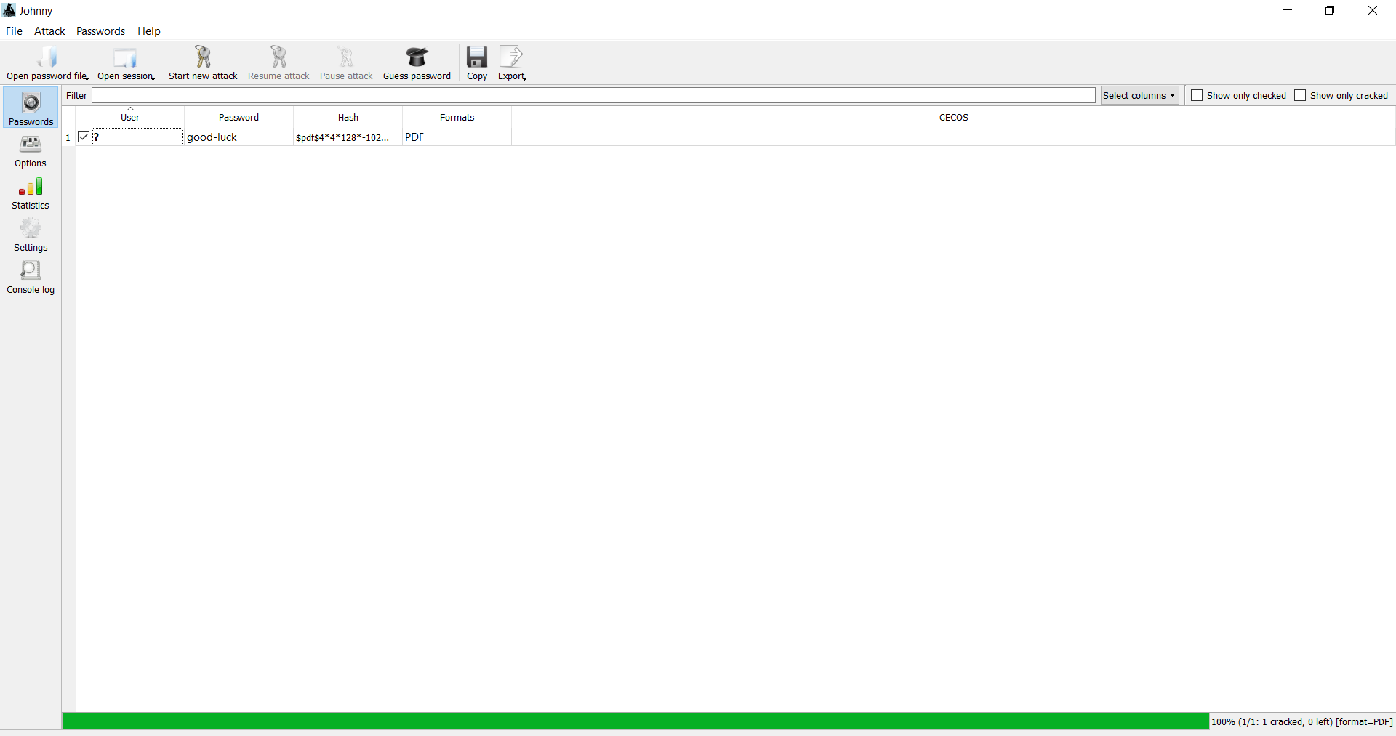
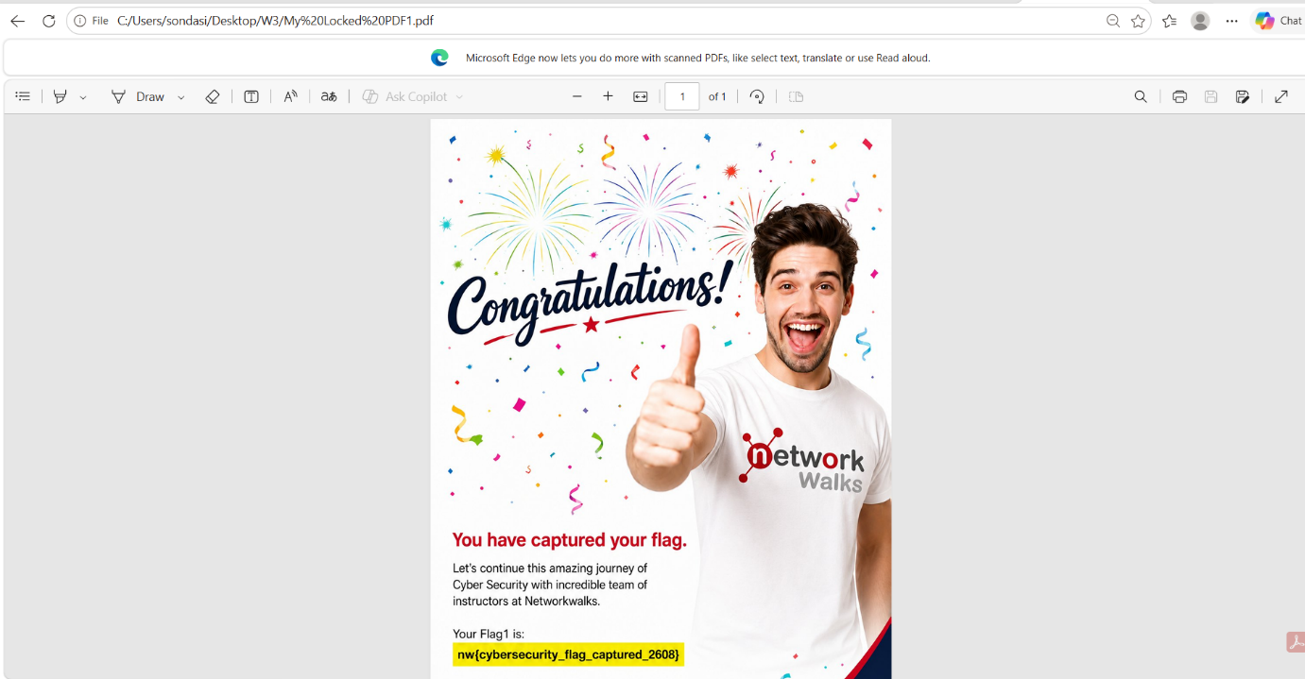
My PDF3
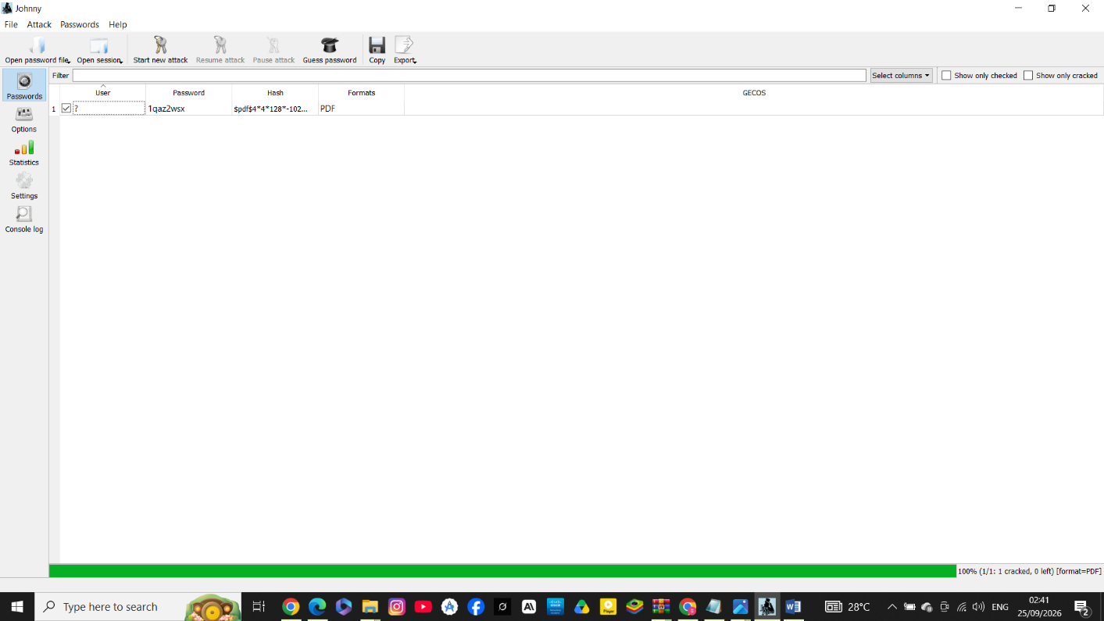
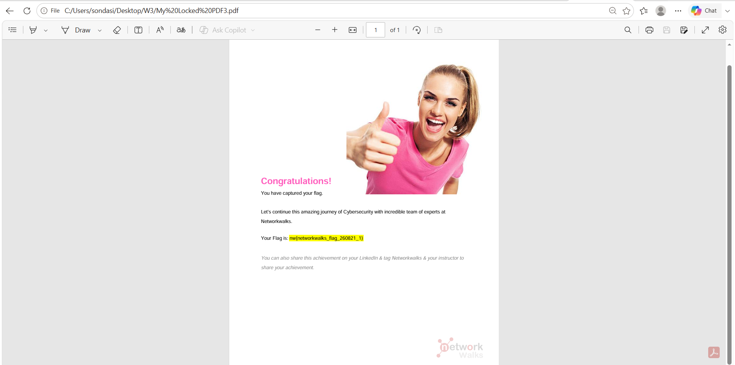

### W3-PM2: Password Cracking with NetworkWalks Tools
**Tools:** NetworkWalks Hash Calculator, NetworkWalks Password Cracker (dictionary attack, browser-based)
**Steps:**
1. Uploaded the locked PDF to the **Hash Calculator** (`networkwalks.com/hash-calculator`) to extract its `$pdf$` hash locally in-browser.
2. Copied the full hash and pasted it into the **Password Cracker** (`networkwalks.com/password-cracker`).
3. Ran the built-in dictionary attack (100-word list) against the hash.
4. Tool matched the password after trying multiple common candidates.
5. Opened the PDF with the cracked password to confirm and capture the flag.

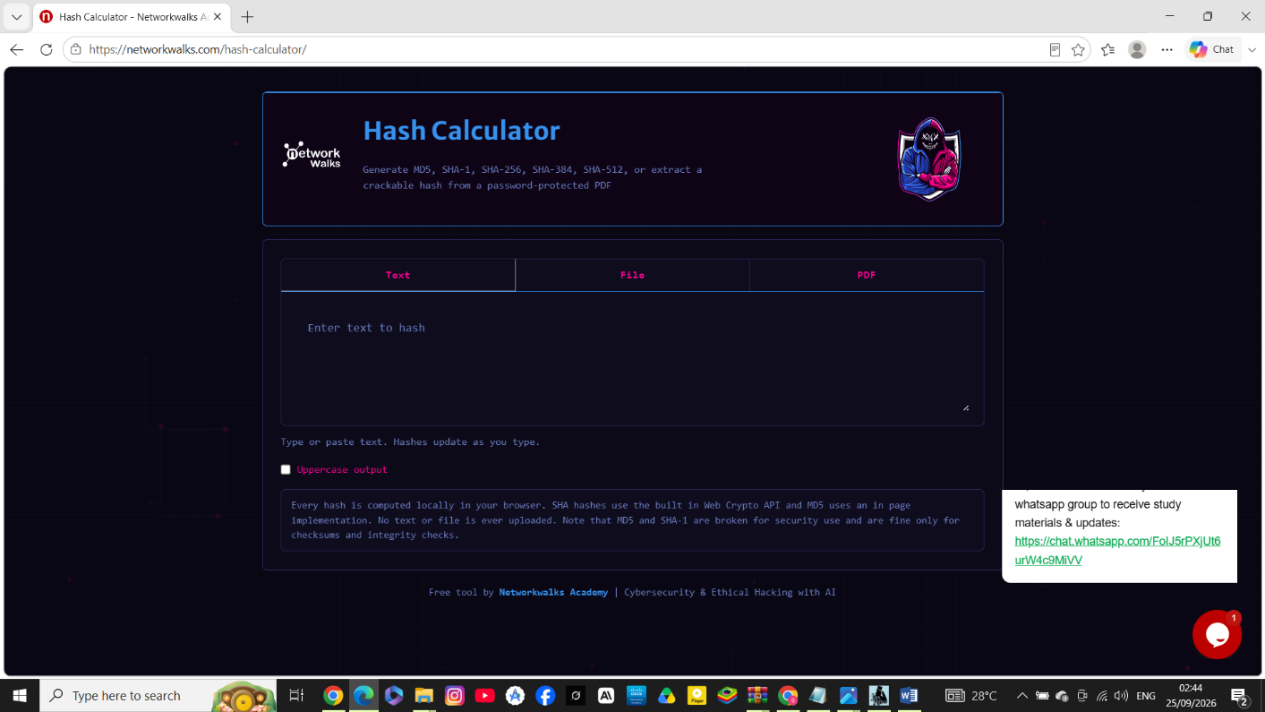
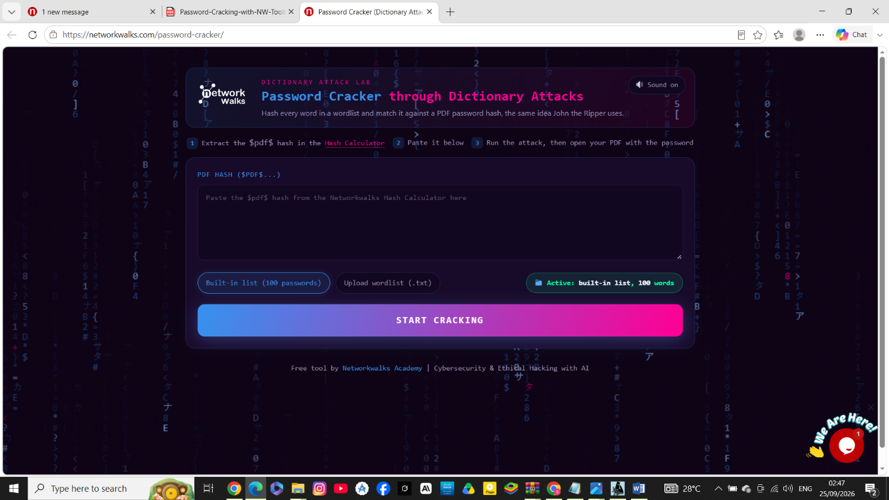
**Results across sample files:**
- `My-Locked-PDF1.pdf` `
- `My-Locked-PDF3.pdf`

**Flags captured:**
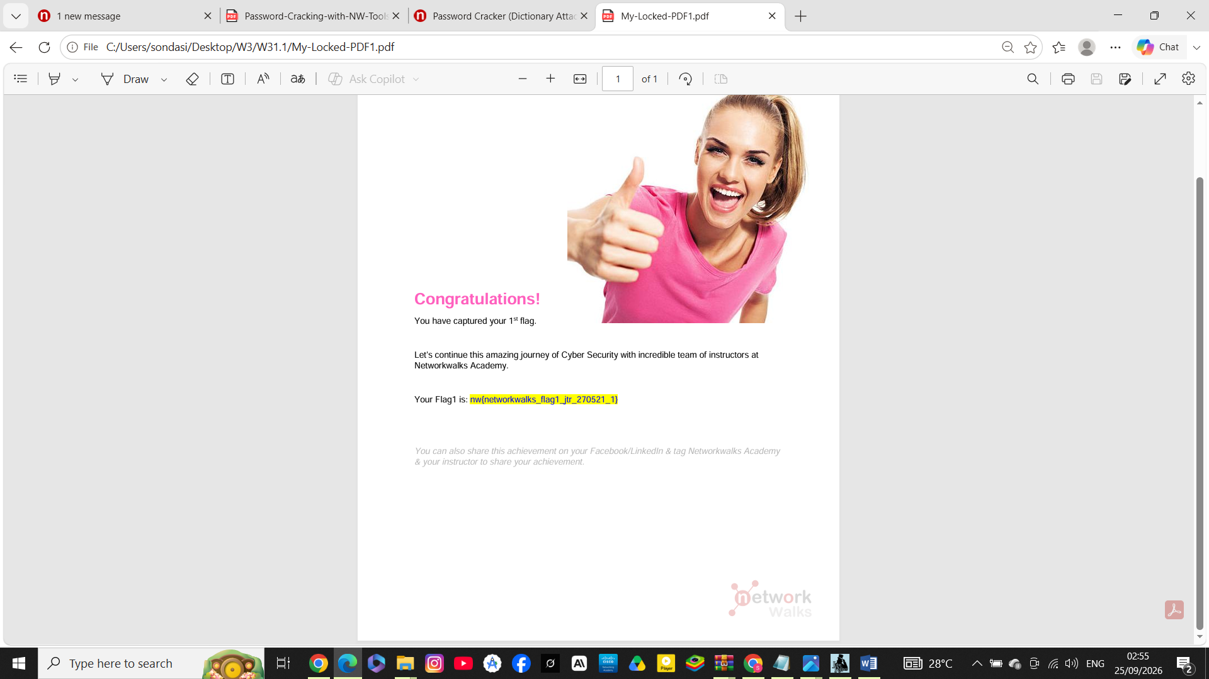
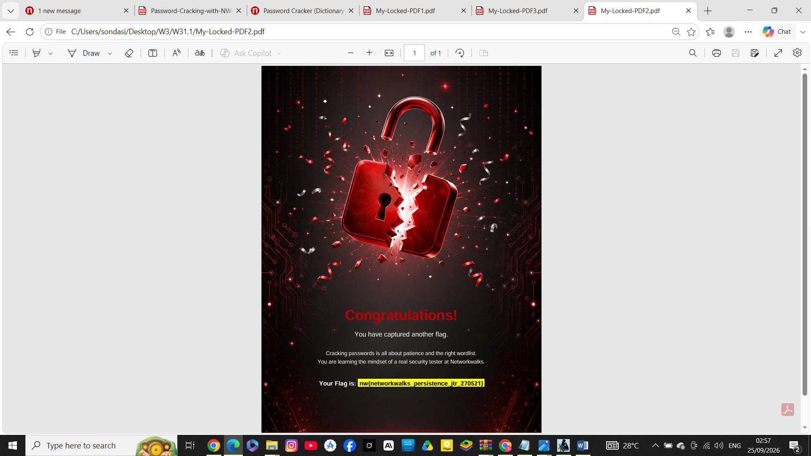
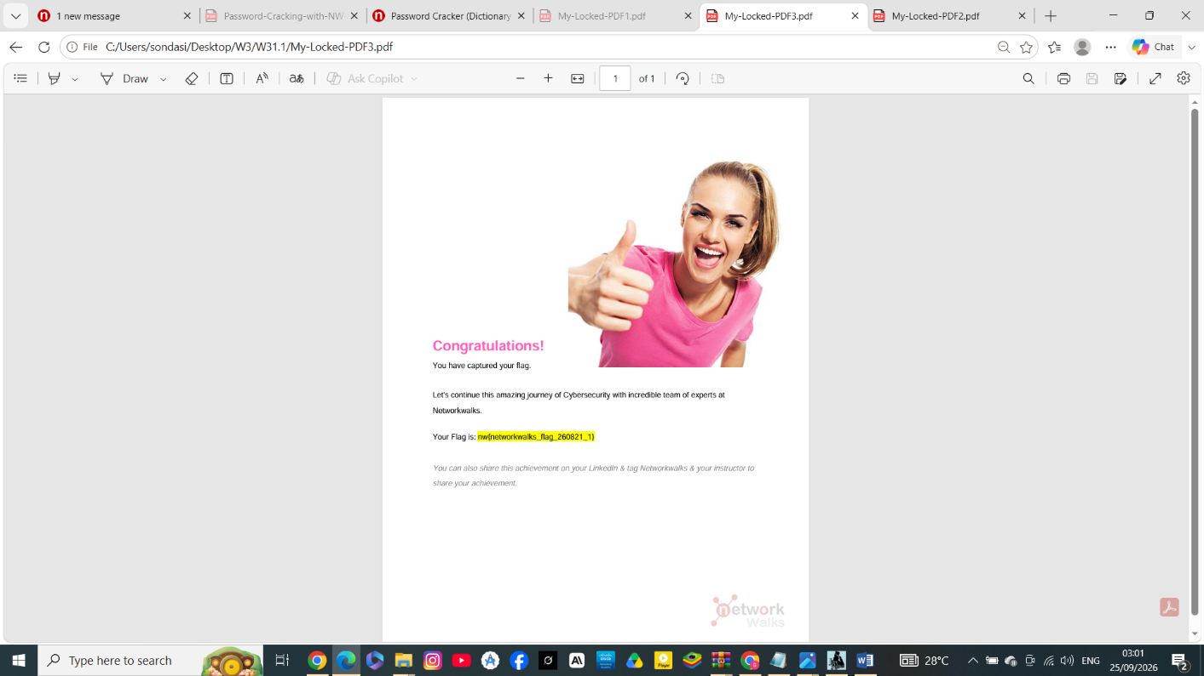
## Key Takeaway
Both a dedicated offline cracking tool (John the Ripper) and a lightweight browser-based dictionary attack were able to recover weak, dictionary-based PDF passwords within seconds — demonstrating why simple/common passwords offer little real protection and why strong, unique passwords matter for encrypted documents.

## Disclaimer
This work was performed in a controlled training lab environment provided by NetworkWalks Academy for educational purposes only, using PDF files intentionally created for this exercise.

---
*NetworkWalks Cybersecurity Internship — Batch B083 — Week 3*

